**WEEK 2 – QUERIES**

**1.List the entire participated relation in the descending order of damage amount.**

**SQL>**select * from participated order by(damage_amout) desc;

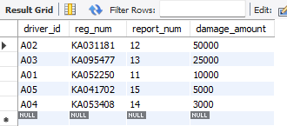

**2.Find the average damage amount**

**SQL>**select avg(damage_amout) from participated;

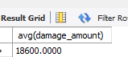

**3.Delete the tuple whose damage amount is below the average damage amount**

**SQL>**delete from participated where damage_amout<( select t.amt from(select avg(damage_amout)as amt from participated) t);

**SQL>**select * from participated;

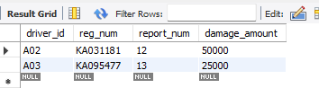

**4.List the name of drivers whose damage is greater than the average damage amount.**

**SQL>**select name from person,participated where person.driver_id=participated.driver_id and damage_amout>(select avg(damage_amout) from participated);

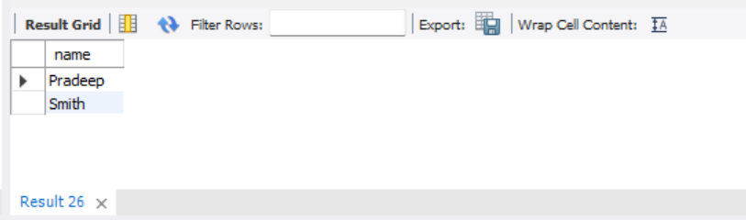

**5.Find maximum damage amount.**

**SQL>**select * from participated;

